Video link

Project Part A: IMDb Movie Review Sentiment Analysis

REPORT

Step-1 : environment

Genism is older library, it will create issues in google colab.
I downgraded version of some of the packages. so the gensim lib is compatible with other libraries.
first executing these commented code lines and restating the session.

!pip uninstall -y gensim numpy scipy
!pip install numpy==1.23.5 scipy==1.10.1 gensim==4.3

Step-2: loading the dataset

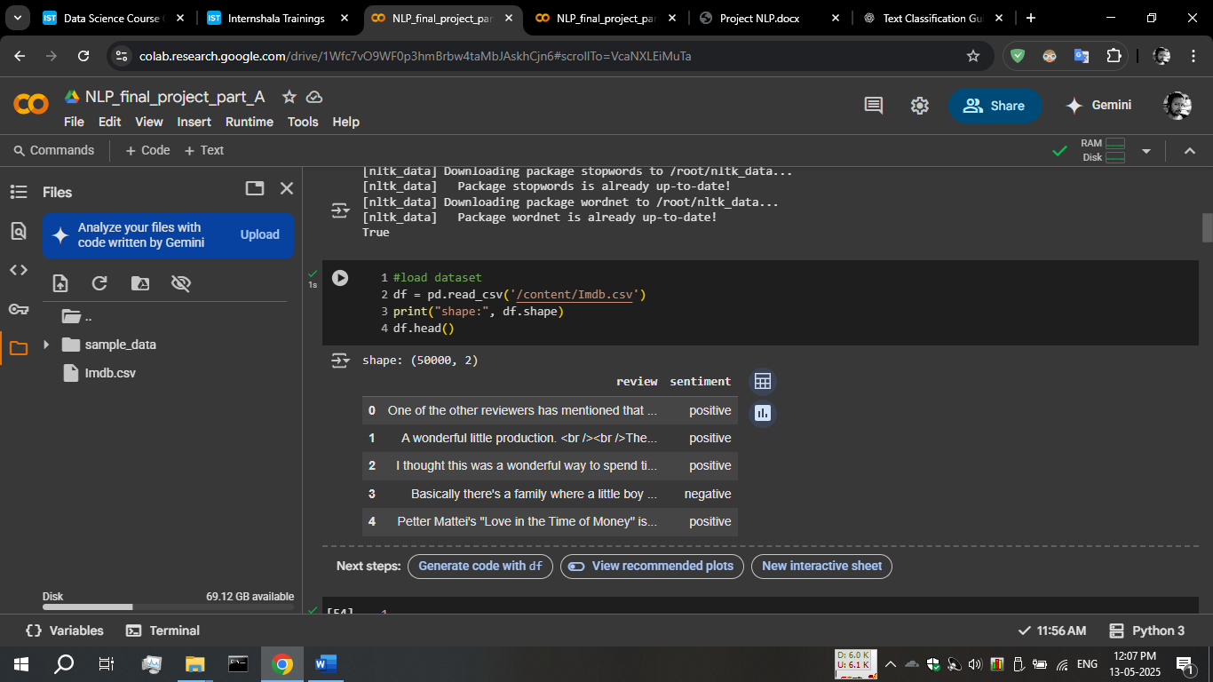
I used upload option in colab,
It appears orange on left side of the image.
I found that this dataset contains 50000 records of data containing reviews and their labelled sentiments.

Step-3: text pre-processing
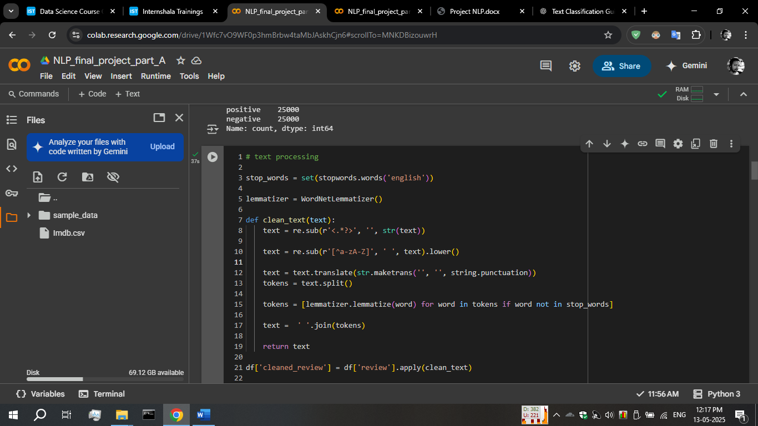
First I loaded the lemmmatizer using WordNetLemmatizer()function
then I created a function clean_text(),
it is used for removing entire html tags.
Then I used maketrans and translate function for removing any punctuation from the given text.
Then I applied lemmatizer for reducing the dimantionality

finally creating new column in dataframe and applying clean_text() function into review column
df['cleaned_review'] = df['review'].apply(clean_text)

step-4: extracting features and vectorization

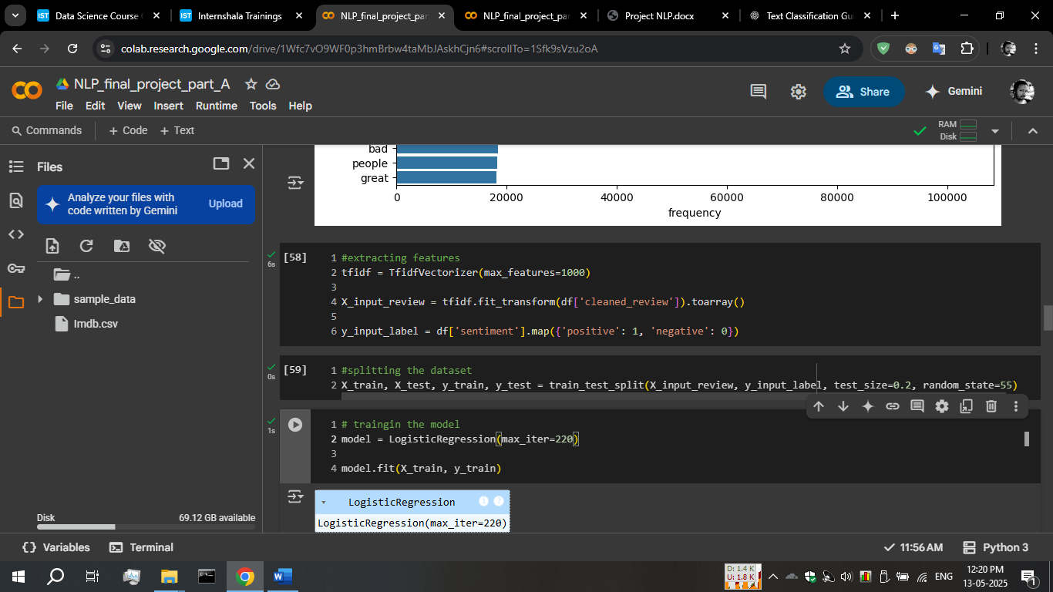
I used TfidfVectroizer for vectorization and then I applied fit_trnsform() function to vectorize the review column
After vectorization, toarray() function is used to make model understand the input data.
In y_input_label,
Sentiment is mapped to its numerical values for the same, so model can understand the input data

Step-5: model training
I’m using LogisticRegression model with iteration of 220.
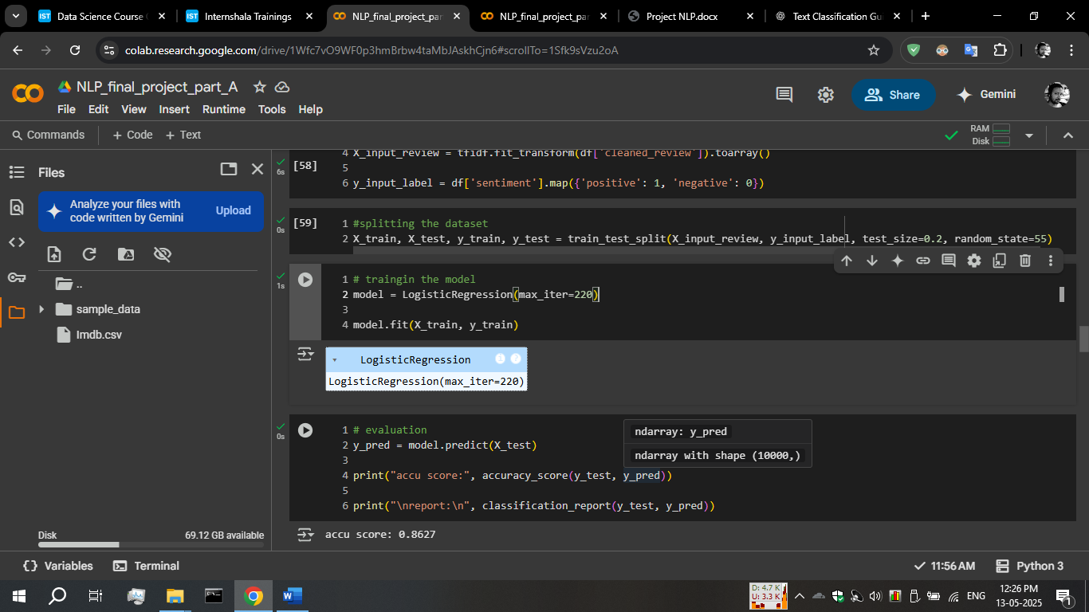

Step-6: evaluating the model

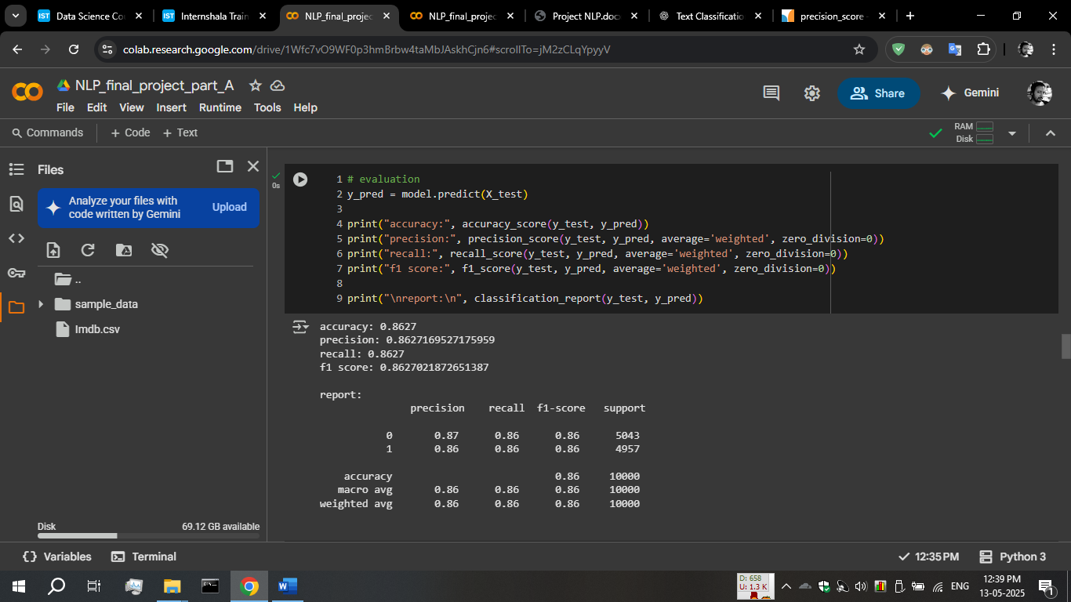
As appears model accuracy is 0.86, model predicts the 86% of the samples correctly.
Precision, recall and f1-score both appears around 86% as well.
So, model performance and prediction capability are fine
Confusion matrix:
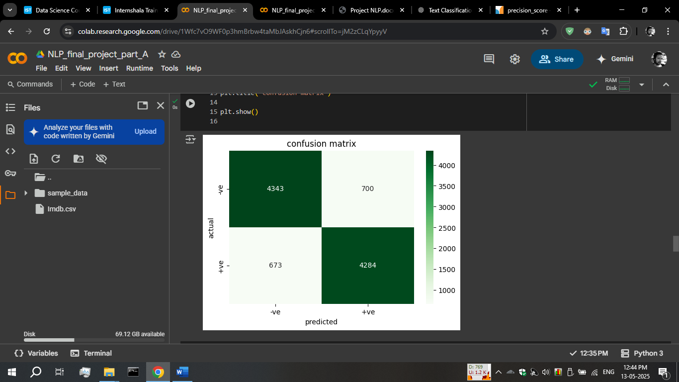
Most of the time model predicting accurate negative and accurate positives, with low false-negatives and false-positives.

ROC curve: our model performing well in distinguishing between two classes (positive or negative in sentiment).

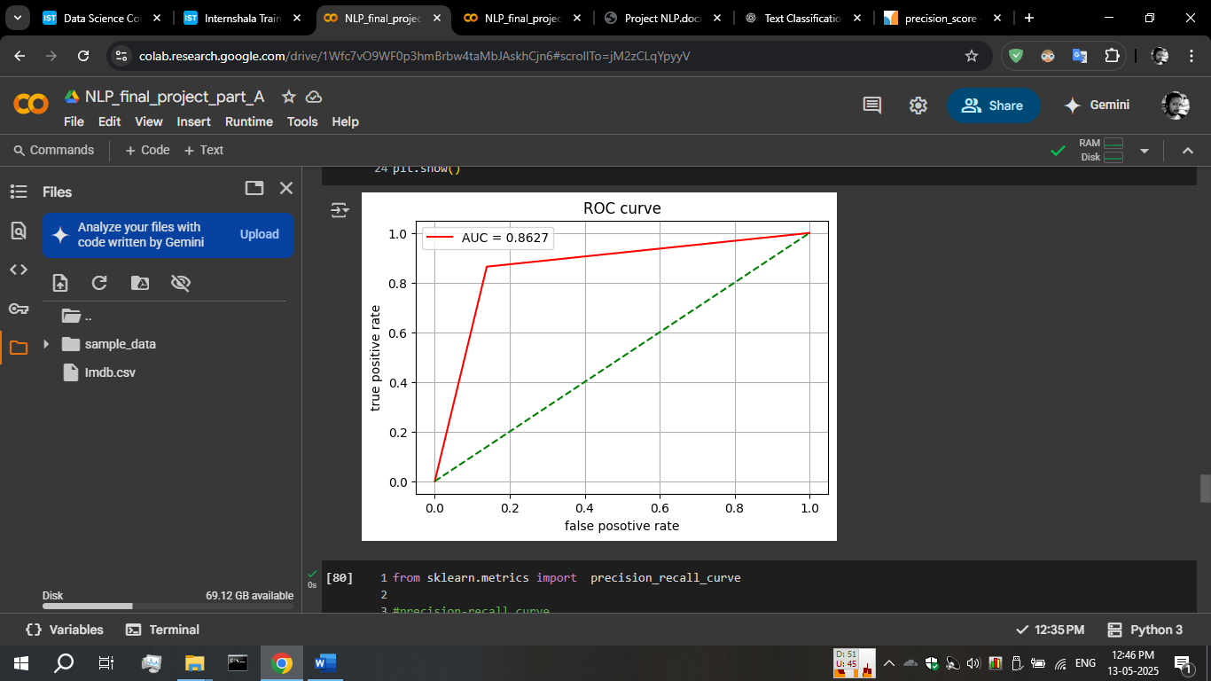

Thank you

